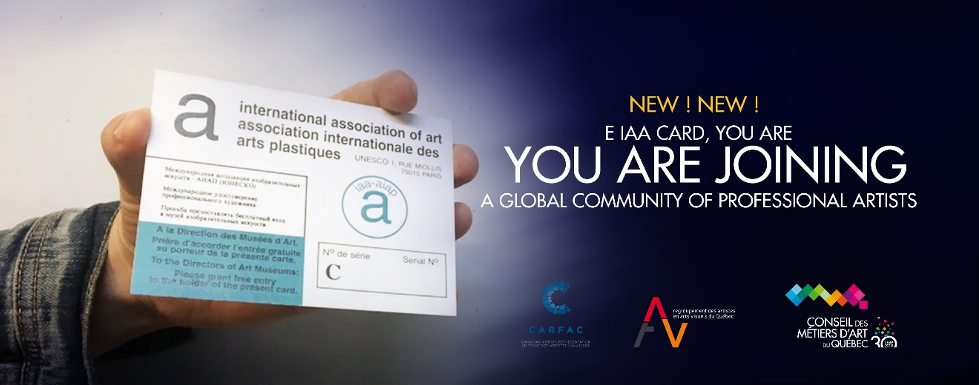

Card Application Form

To start enjoying the benefits of your IAA card, complete the attached form.

Your card allows free admission to a number of galleries and museums around the world. “It also allows you to prove, when going through customs, that you are the owner.” https://www.aiap-iaa.org/membership.card.htm

Please read carefully the information below.
**************
To be eligible for the IAA card, you must:
- Be in good standing as a professional member of CMAQ
- Complete the identification form below and return it to us
- Enclose (one) “ID size” photo: 1-¼” x 1-¼”
***digital photos are not accepted
Pay the fee of $10.00 (taxes and delivery included) by: Visa, MasterCard, PayPal, cheque or cash
$8,⁴⁰ before taxes + 0,44 % (TPS) + 0,87 % (TVQ) = $10,⁰⁰
Once we have received all the documents, the application will be forwarded to CARFAC. You will receive your IAA card within four weeks.
We would also like to remind you that, before leaving on a trip, it is always a good idea to consult the list of museums that offer free or discounted admission. This list is available on CMAQ's website.

For more information:

Hélène Cloutier
Service Coordinator – CMAQ
Phone: 514-861-2787, ext. 212
Email: helene.cloutier@metiersdart.ca

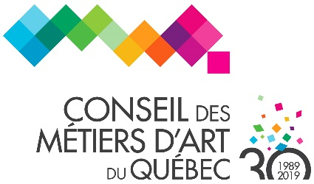
Payment Form

IDENTIFICATION
Ms. Mr. N/A
LAST NAME: Click here to enter text. FIRST NAME: Click here to enter text.
ADDRESS: Click here to enter text.
CITY: Click here to enter text. PROVINCE: Click here to enter text.
POSTAL CODE: Click here to enter text.
YOUR CMAQ MEMBER NUMBER: Click here to enter text.
--------------------------------------------------------------------------------------------------------------------------------
PAYMENT
PAYMENT METHOD*: Visa Mastercard American Express
Cheque Cash

CARDHOLDER NAME: CARD NUMBER:

SECURITY CODE: EXPIRY DATE:

AUTHORIZED AMOUNT: SIGNATURE: ___________________________
$10,00 taxes and delivery included
CMAQ TPS 5 % (# 126185784RT0001) TVQ 9,5 % (#1010829808TQ0001)

* Make cheques payable to the “Conseil des métiers d’art du Québec” and reference “UNESCO IAA Card.”

Returned cheques will be assessed a fee of $50 plus taxes. A receipt will be issued.

DATE: _______________________

SIGNATURE: _____________________________

Return this form to Hélène Cloutier, CMAQ Service Coordinator, by:

- Post or in person: Bonsecours Market, 390 St-Paul St E, Suite 400, Montréal (Quebec) H2Y 1H2

